
Disease-causing organisms in water and milk are killed by exposure to heat in a process known as pasteurization. Boil- ing is often recommended to achieve pasteurization. However contaminated water and milk can be pasteurized at temperatures well below boiling.

WAPI’s can save time and fuel! Water heated to 149 degrees F (65 degrees C) for a short period of time is free from microbes, including E Coli, Rotaviruses; Giardia and Hepatitis A virus. At 160 F (71 degrees C) milk and food are pasteurized.
The reusable Water Pasteurization Indicator (WAPI) is a simple, low cost device containing a special soy wax that helps users to determine when water has reached pasteurization temperatures.
What is a WAPI?
OPEN FLAME PASTEURIZATION INSTRUCTIONS FOR WAPIs WITH STAINLESS STEEL WIRE
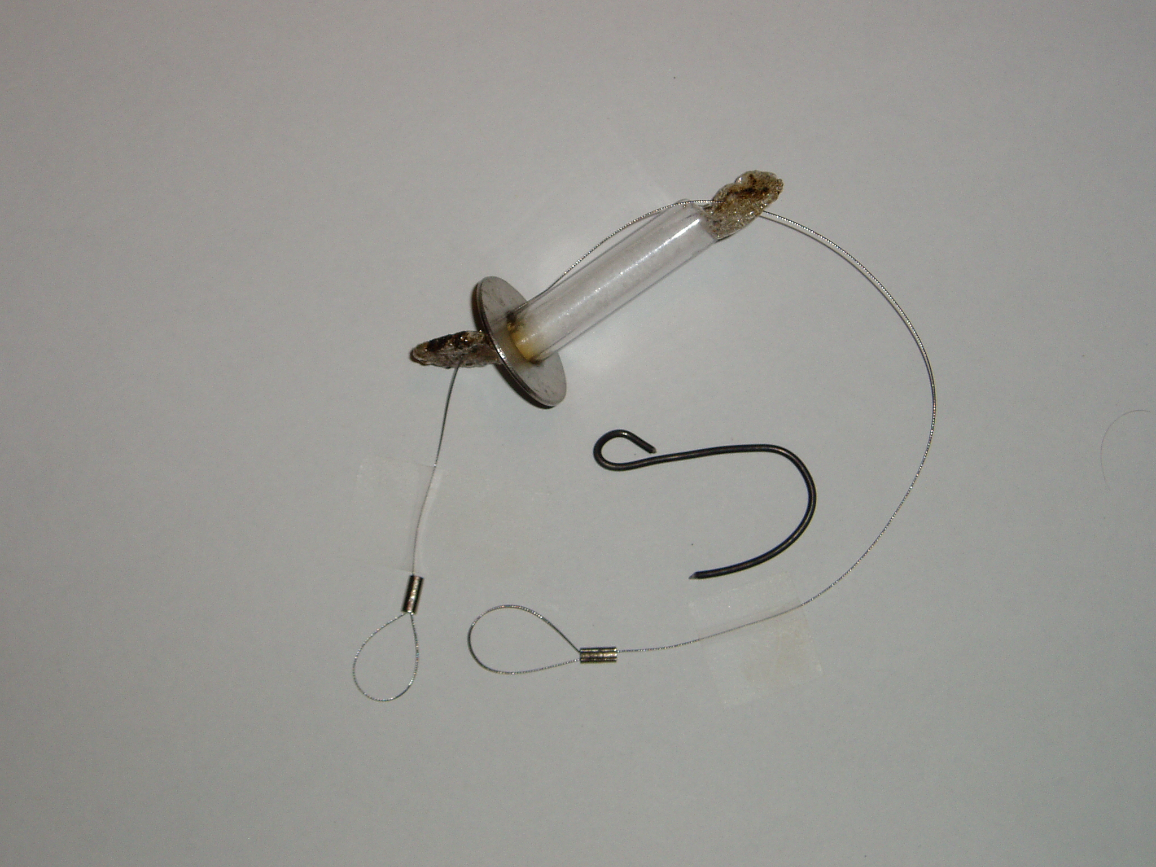
SAFETY NOTICE: Pasteurization does not remove dangerous chemicals, like arsenic. Pasteurization is not the same as sterilization, a process where everything including heat resistant spores, is killed. The heat resistant spores that survive pasteurization are harmless to drink. Where sterilized liquids are needed (in hospitals for example) high temperatures are achieved using special pressure cookers.
IMPORTANCE OF PASTEURIZATION
Water related diseases are responsible for 80% of all illnesses and deaths in the developing world. An estimated 1.5 billion cases of diarrhea occur each year, resulting in the deaths of nearly 2 million children. Worldwide, about 1.3 billion people do not have access to safe drinking water, including nearly half of the population of Sub-Sahara Africa.

WAPI PASTEURIZATION
The new Stainless Steel WAPI can be used for pasteurizing over open flame fuel sources including wood, charcoal and gas. And it still works well in conjunction with a solar cooker. With good sun, simple solar cookers like the Solar Cookers International "Cookit" and common solar box cookers can pasteurize water for a family at a rate of about one liter per hour.
1. Pour water into a pot or a deep pan that can be used with open flame heat.
Thin metal pans with lids are ideal.

2. Place a WAPI, washer down and wax up, into the water with the end of the string outside of the pot or jar.
The washer end of the WAPI should rest on the bottom of the pot or jar and the wax end should be higher. Replace the lid.
Please Note: When using the WAPI for the first time, the wax might be in powder or pellet form and will slide to the bottom of the tube with the large washer. The wax will begin to melt at 160 degrees F and become clear at the bottom of the tube. When you take it out of the fluid and cool the tube the wax will also cool and become a solid mass. In each use thereafter follow the instructions in 2.

3. If needed, place the large loop of the “S Hook” on the lip of the pan and attach top loop of the WAPI to the inside small loop of the S hook. This will prevent the wire from falling into the pot.
.
4. Set the pot or pan on the fire.
WAPI after Pasteurizing

5. When the WAPI wax melts and falls to the bottom of the WAPI, the water has been pasteurized.
Even if the water has cooled by the time you check it, as long as the wax is at the bottom of the WAPI, then pasteurization has occurred.
6. Allow the water to cool before Drinking!

7. Keep the water covered until use to
Prevent recontamination.
Don't let fingers or unclean objects touch
clean water.

8. If you aren't sure, re-pasteurize the water.

9. Allow the wax in the WAPI to solidify. Turn it over and pull the wire though to the other end. The WAPI is now ready for the next use.

NOTE: If the WAPI is too long for the pan, attach both wire loops to the S-hook and adjust the WAPI tube so the wax is at the top.

Stainless Steel WAPI
With “S” hook
This WAPI sponsored by WAPI Kit Project, Monterey Peninsula Sunrise Rotary, Monterey, CA USA
For more informationr contact Wapi@pacbell.net



